Faith Lutheran Church – DECEMBER, 2025
Sunday | Monday | Tuesday | Wednesday | Thursday | Friday | Saturday
 |  |  | 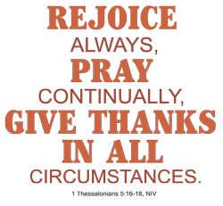 |  |  | 
 | 1) 8a P & C @ Wendy’s  10a V. V. Worship/HC  6p Mission & Outreach  7:30p Dartball – Home  Vs. Grace | 2)  6p Congregational  Christmas Dinner Out –  Oak and Anchor Rest. – Oak Harbor, OH | 3)  6:15p Bell Choir  7:15p Praise Choir  7:15p Sr. Choir  8:05p Cantata Practice | 4) 9-3p Fellowship &  Sew Day  3p Christ Care | 5) | 6)  9:15a ChristCare
7)  8 & 10:30a Worship/H. Communion  9:15a Sunday School & Fellowship | 8)  8a Men’s Group-Hall  10a V.V.–Tea Time  11:30a FLCW Visitation  At Bob Evans  7:30p Dartball - Away  Vs. St. John’s | 9)  6:30p FLCW Dec. Gen.  Meeting  7p Program – Christmas  In the Trenches-with  Mike Gilbert | 10) OFFICE CLOSED  6:15p Bell Choir  7:15p Praise Choir  7:15p Sr. Choir  8:05p Cantata Practice | 11)  3p Christ Care | 12) OFFICE  OPEN | 13)  9:15a ChristCare  1-5p Hall Reserved -  Jane Frederick
14) 8a Children’s Christmas Prog.  8a Worship/H. Communion  10:30a Worship/H. Communion  9:15a Sunday School & Fellowship | 15)  10a V.V. Worship/HC  7:30p Dartball – Home  Vs. St. John’s | 16)  6:30p Church Council  With new members too! | 17)  6:15p Bell Choir  7:15p Praise Choir  7:15p Sr. Choir  8:05p Cantata Practice | 18) 9-3p Fellowship &  Sew Day  3p Christ Care | 19)  5p Neill Wedding  Rehearsal  Hall Reserved | 20)  9:15a ChristCare  1:30p Kyle Neill  Wedding
21) 8a Worship/H. Communion  10:30a Christmas Cantata  10:30a Worship/H. C.  9:15a Sunday School & Fellowship  NEWSLETTER  ARTICLES DUE | 22) OFFICE OPEN  8a Men’s Group - Hall  10a V.View–Tea Time  with God | 23) | 24) OFFICE CLOSED  CHRISTMAS EVE  4p Christmas Candlelight  Service with H.C.  7p Christmas Candlelight  Service with H.C. |   25) OFFICE CLOSED | 26) OFFICE  OPEN | 27)
28)  9a Worship/H. Communion  10a Sunday School & Fellowship | 29) OFFICE OPEN  10a V. View – Christmas  Carols | 30) | 31) OFFICE CLOSED  NEW YEAR’S EVE | 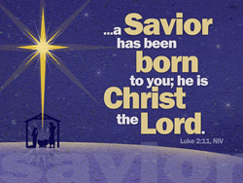 |  | 